[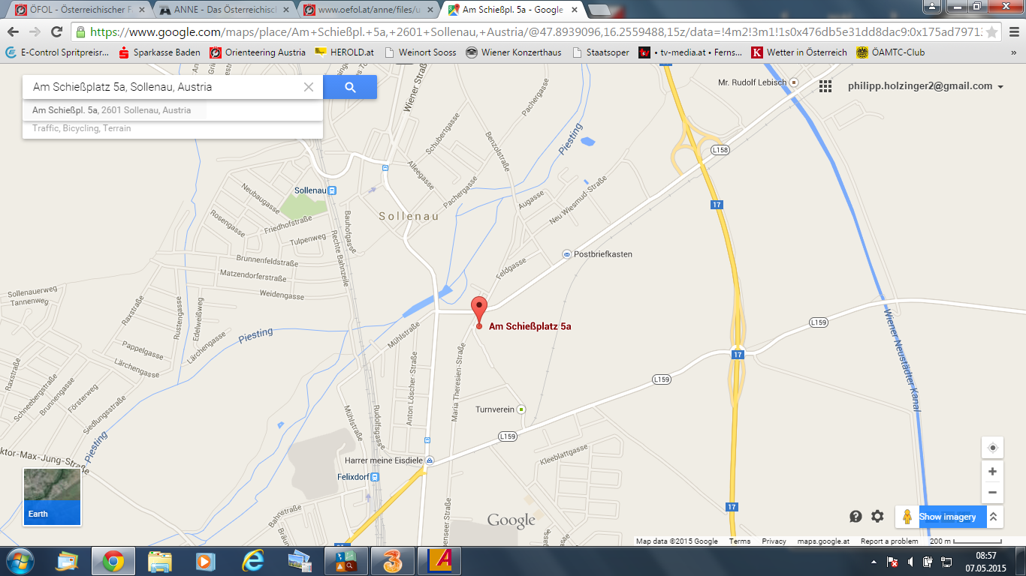](https://www.google.com/maps/place/Am+Schie%C3%9Fpl.+5a,+2601+Sollenau,+Austria/@47.8939096,16.2559488,15z/data=!4m2!3m1!1s0x476db5e31dd8dac9:0x175ad797132e163d)